# Challenge:-

|  |  |  |
| --- | --- | --- |
| **Assignment Date** | 26 September 2022 |  |
| **Student Name** | Ayman Abdul Kader |  |
| **Student Roll Number** | 960519205005 |  |
| **Maximum Marks** | 2 Marks |  |

Upload the dataset to Cognos Analytics, prepare the data, explore and Create Interactive Dashboard.

# Solution:

## LOCATION COLOURED BY SALES? SOLUTION

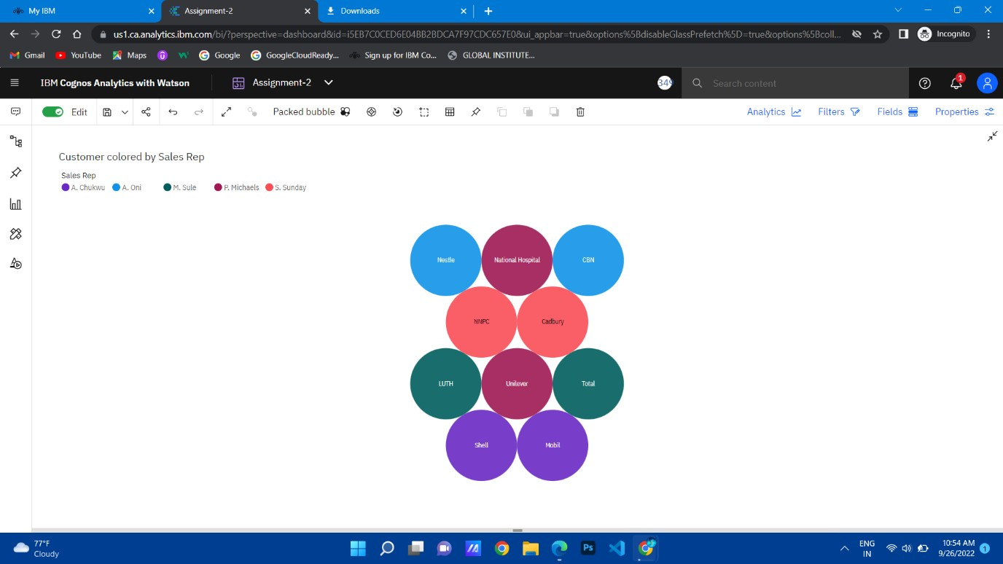

1. 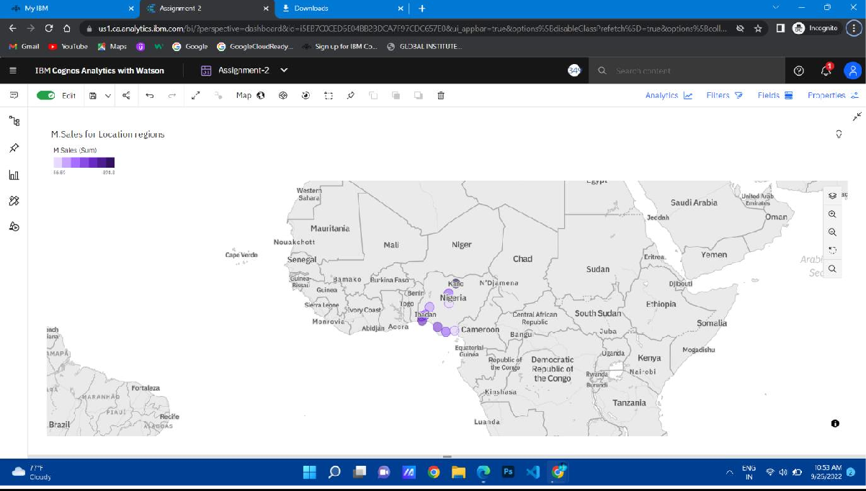**INVERTORY STOCK BY WARE HOUSE? SOLUTION**
2. **ACTUAL AND INVENTORY STOCK BY MONTH? SOLUTION**

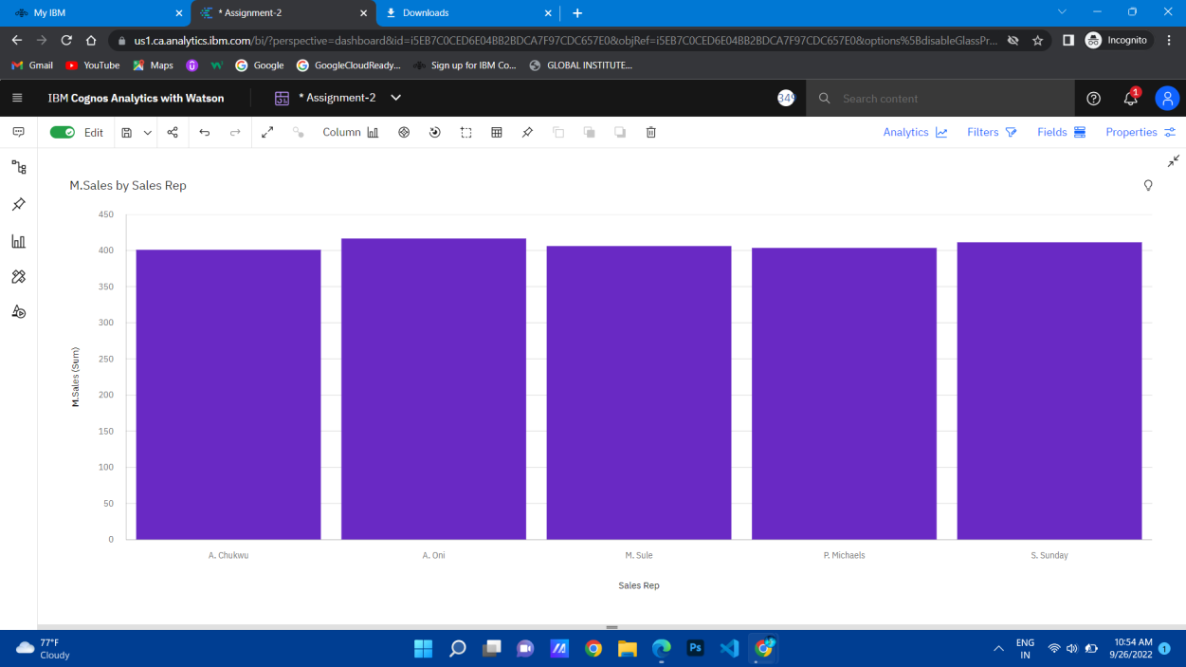

1. **SUPPLIER SIZED BY INVENTORY STOCK? SOLUTION**

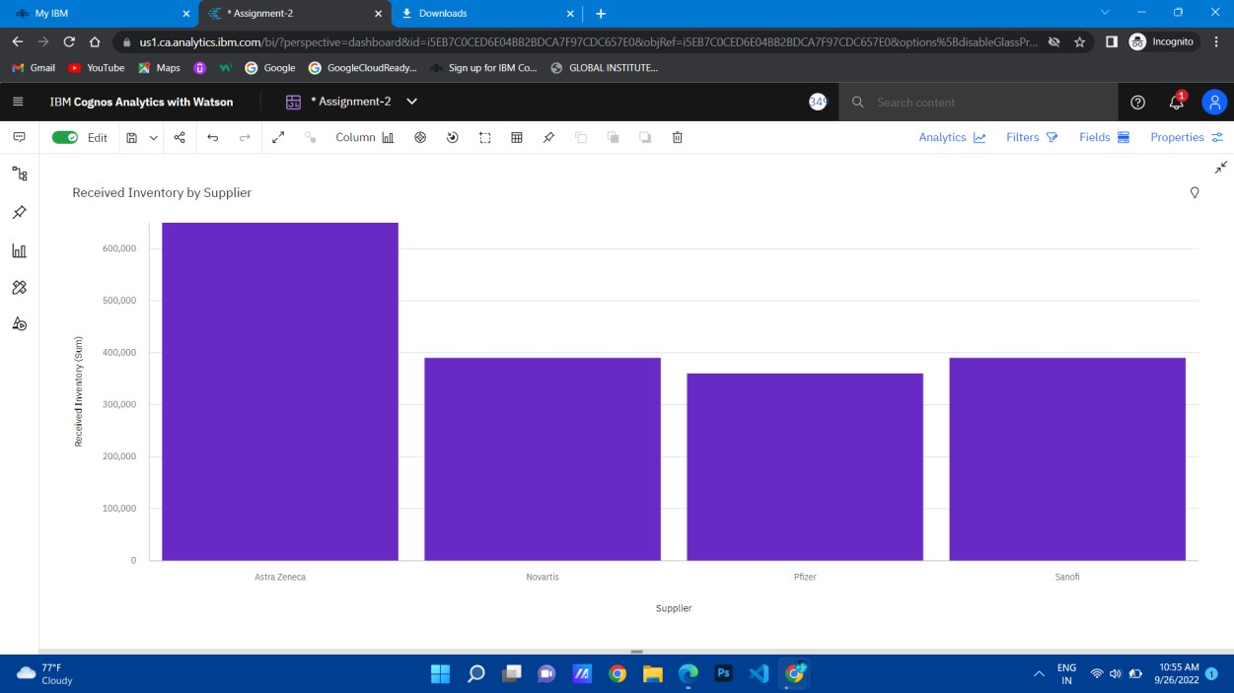

1. **CUSTOMER BY MONTH COLOURED BY SUPPLIER? SOLUTION**

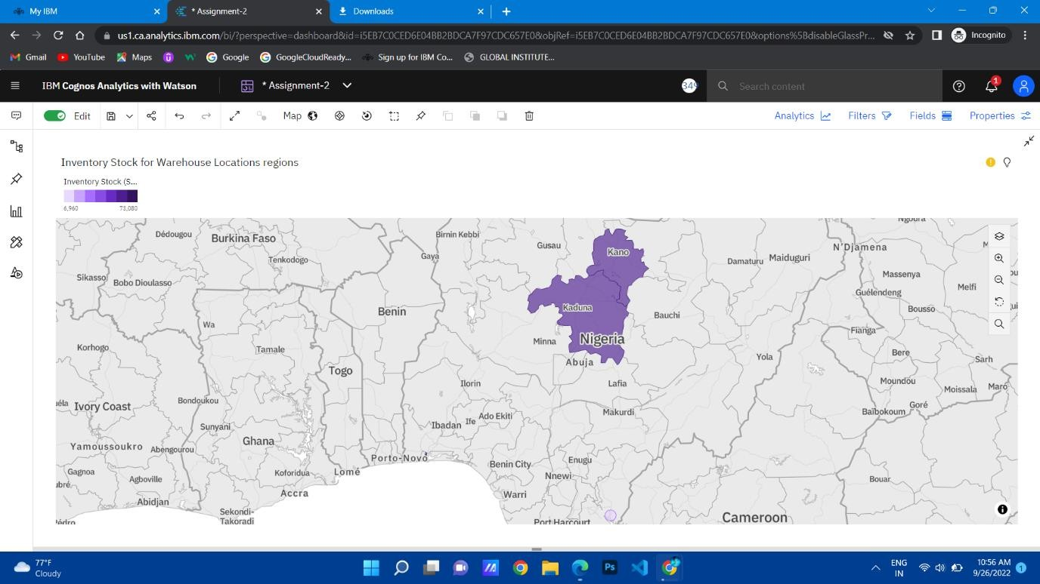

1. 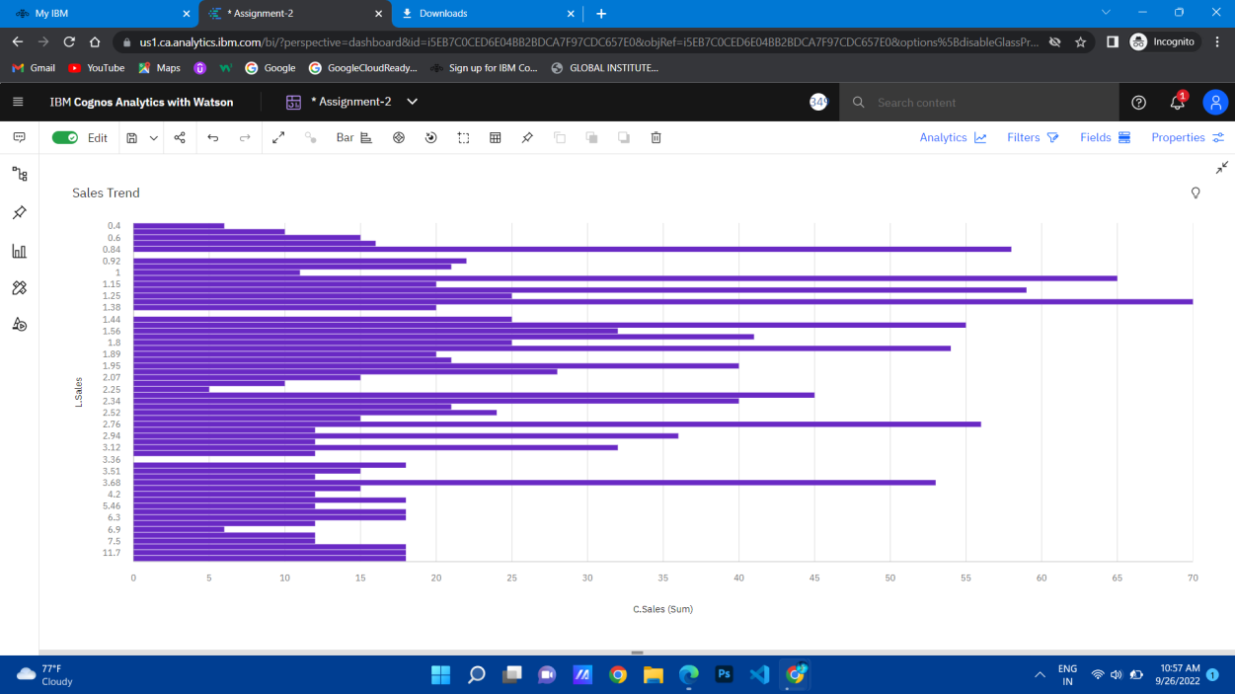**SALES BY CUSTOMER? SOLUTION**
2. 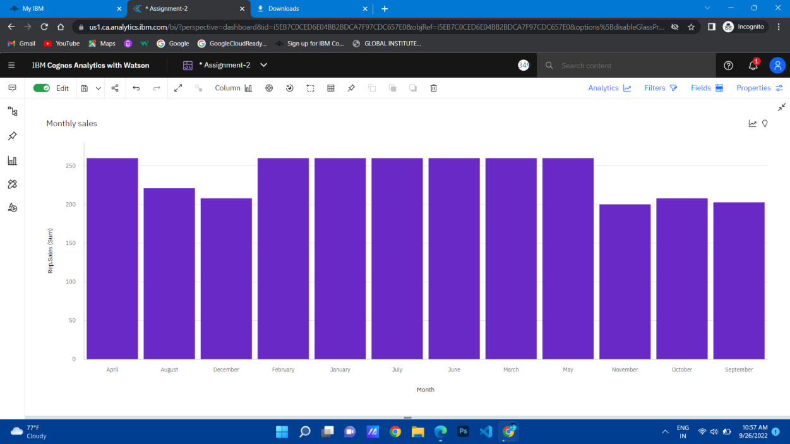**SALES BY SALES REP? SOLUTION**
3. **TARGET FOR SALES REP?**

SOLUTION

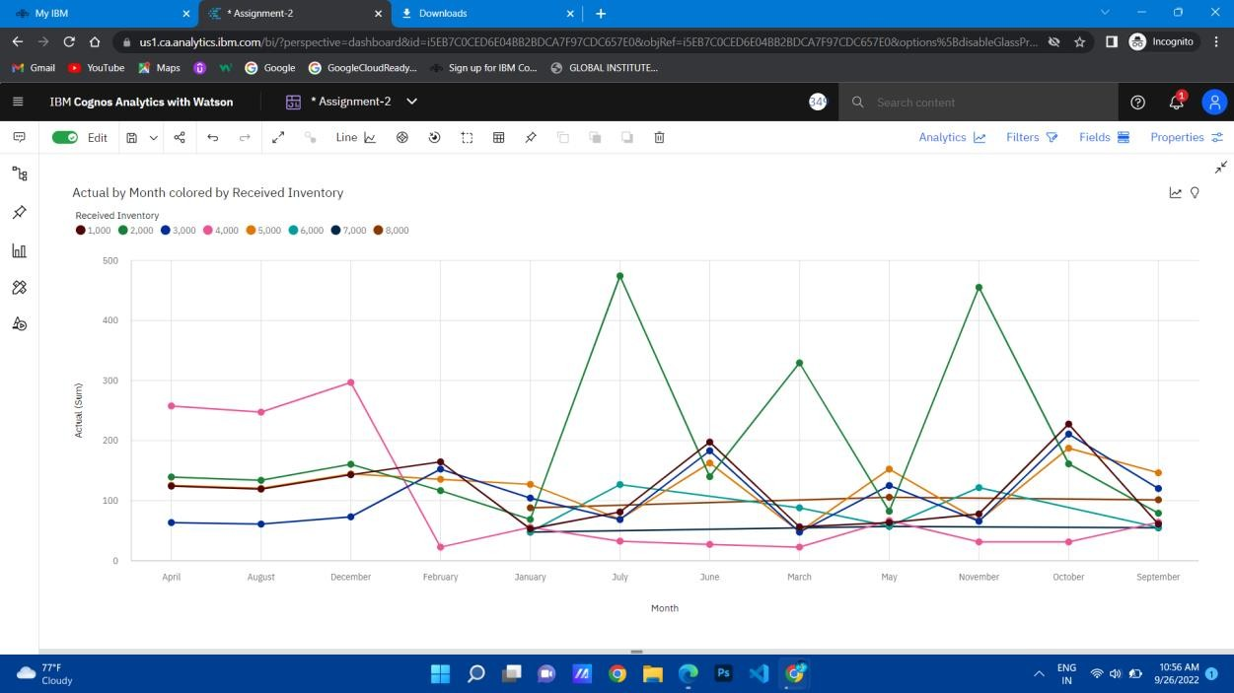

**REFERENCE LINK**

https://us1.ca.analytics.ibm.com/bi/?perspective=dashboard&pathRef

=.my_folders%2Fdashboard%2FAssignment- 2&action=view&mode=dashboard&subView=model000001837835b857_ 00000001